Health Care Report

FIRST QUESTION

1.Open Excel and load the csv file into the Excel.

2.Preparation of the Data :

Ensure the data is correctly formatted. Each column should have a header and should represent the patient data.

3.Extraction of Months from Admission Dates :

* Insert a new column next to the Admission Data namely “Month-Year”. Use the formula namely “Text” and extract the month and year from the column.
* 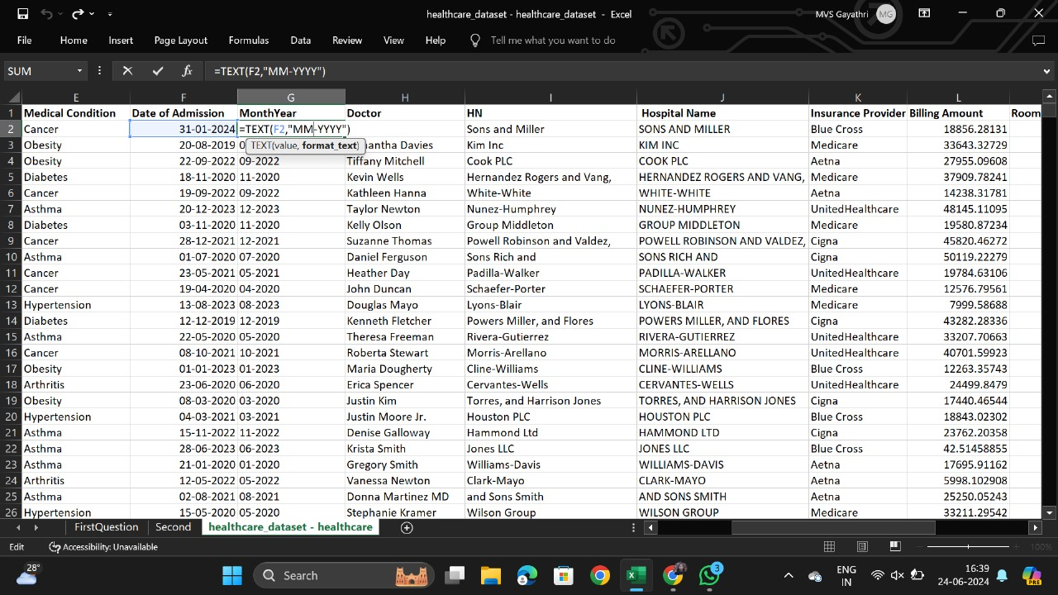Drag the formula to the entire column.

4.Select the entire data range Go to insert and insert a pivot Table in a new worksheet.

5.In the Pivot Table Field List, drag the “Month-Year” field to the Rows area. Drag the another field “Name” to the Values area and set it to count.

6.Sort the Pivot Table data Count of the patients in Descending order.

1. Take a note of the Month-Year with Highest count.

1. Calculate the sum of the bill at that particular month using function namely “Sumifs”, entering the criteria and the range , will get the total billing of the month .
2. By Following these steps , We will be able to determine the month with the highest patient admissions and the Total bill for that month.

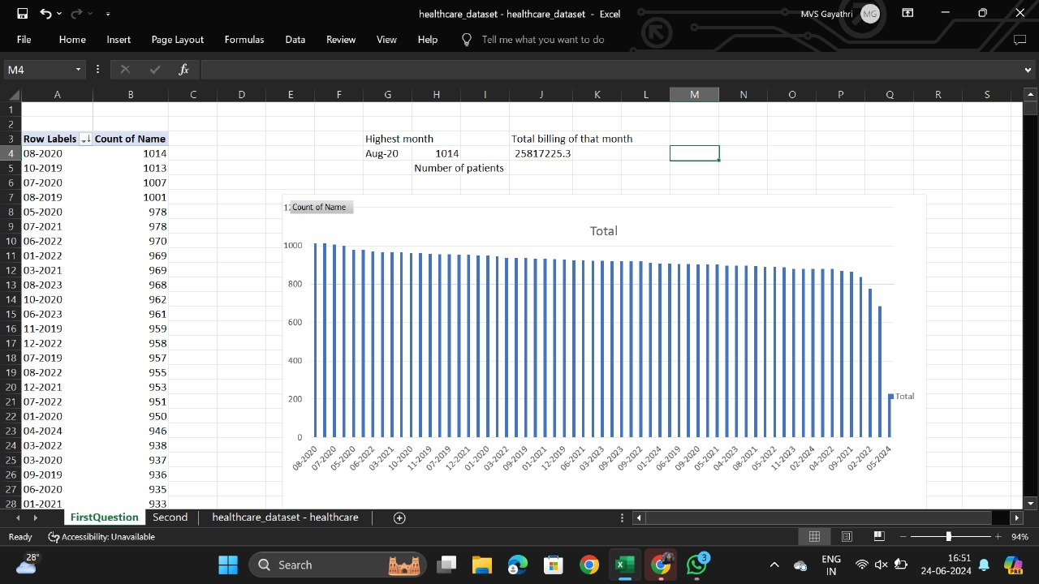

SECOND QUESTION

1. Use the Excel function namely “ TRIM” to remove extra spaces and “UPPER” to Standardize the case.

11 . Select the entire data range and insert a Pivot Table in the new worksheet.

12 . In the pivot table Field List, drag the “Hospital Name” field to the Rows area. Drag the another field “Name” to the Values area and set it to count.

13. Sort the Pivot Table data Count of the patients in Descending order.

14. Take a note of the Hospital with highest count of admissions.

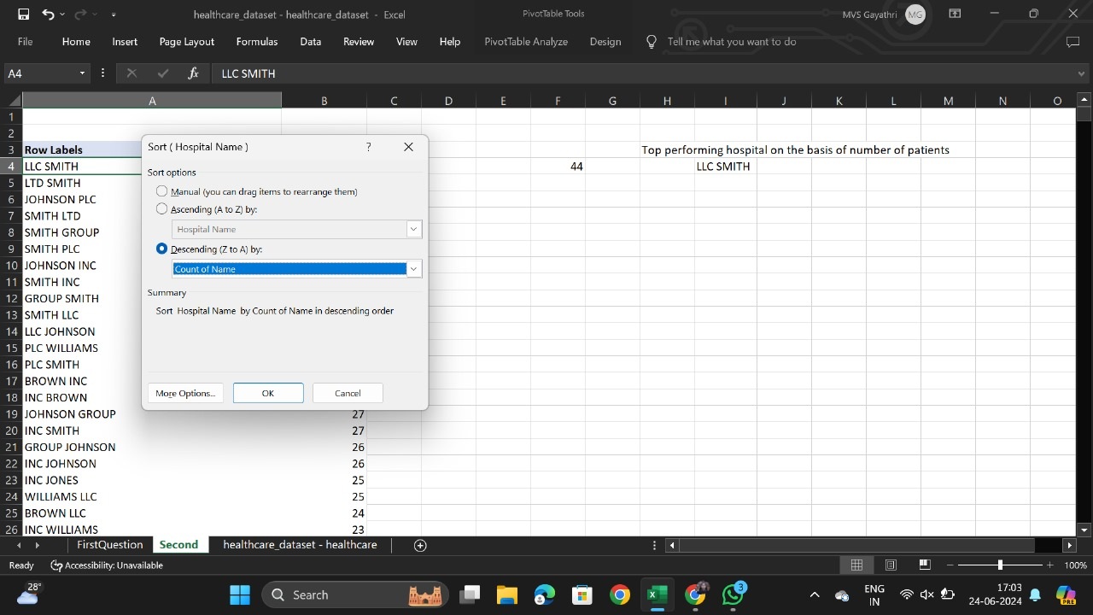

15. By following these steps , We will be able to determine which hospital recorded with the highest number of patient admissions based on the hospital information.

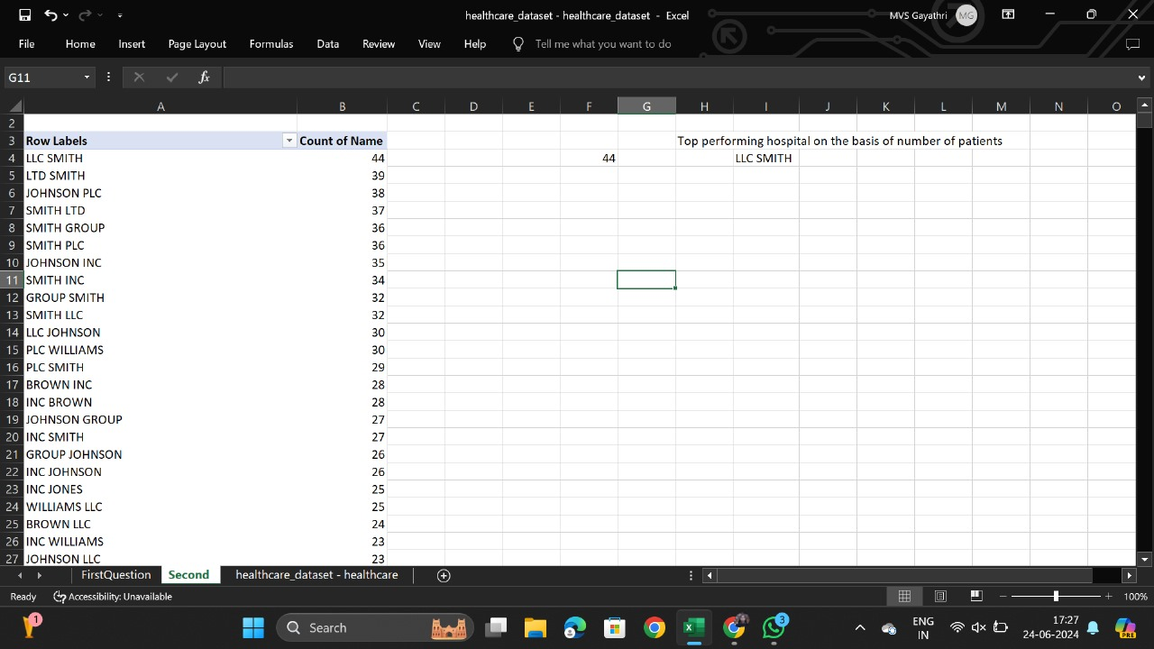

16. The result is the “LLC SMITH” Hospital which have recorded the highest number of admissions.

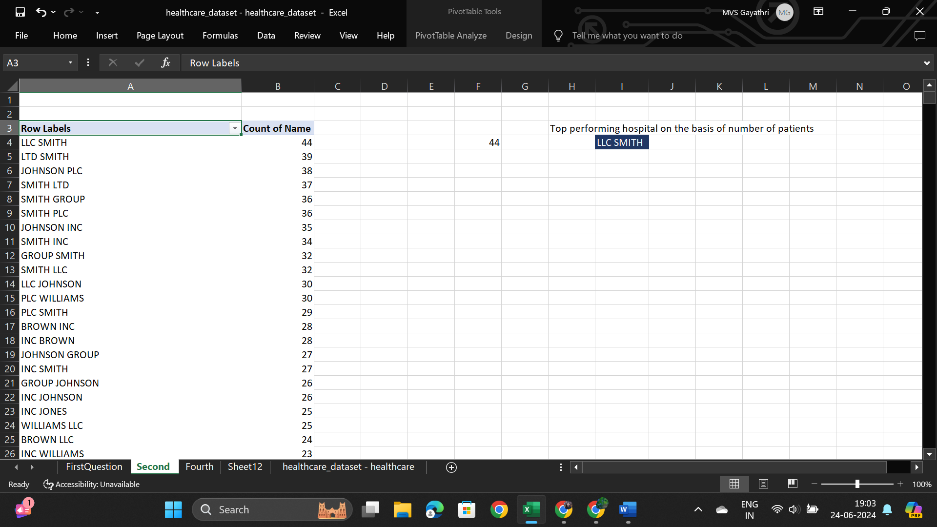

THIRD QUESTION

1. Add a new column named “Day of Week” and in that column use the formula “= TEXT ([date],”dddd”)” because it will convert the date into day.

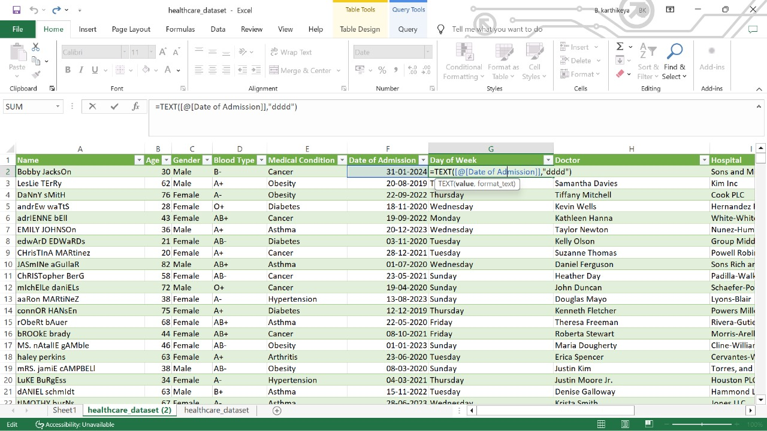

1. Select the data range and insert the pivot table “(Insert > Pivot Table )”.Drag the “Day of week” to rows and   
   “Date of Admission “ to values .
2. Identify the highest day of admissions through the pivot chart that you have made .

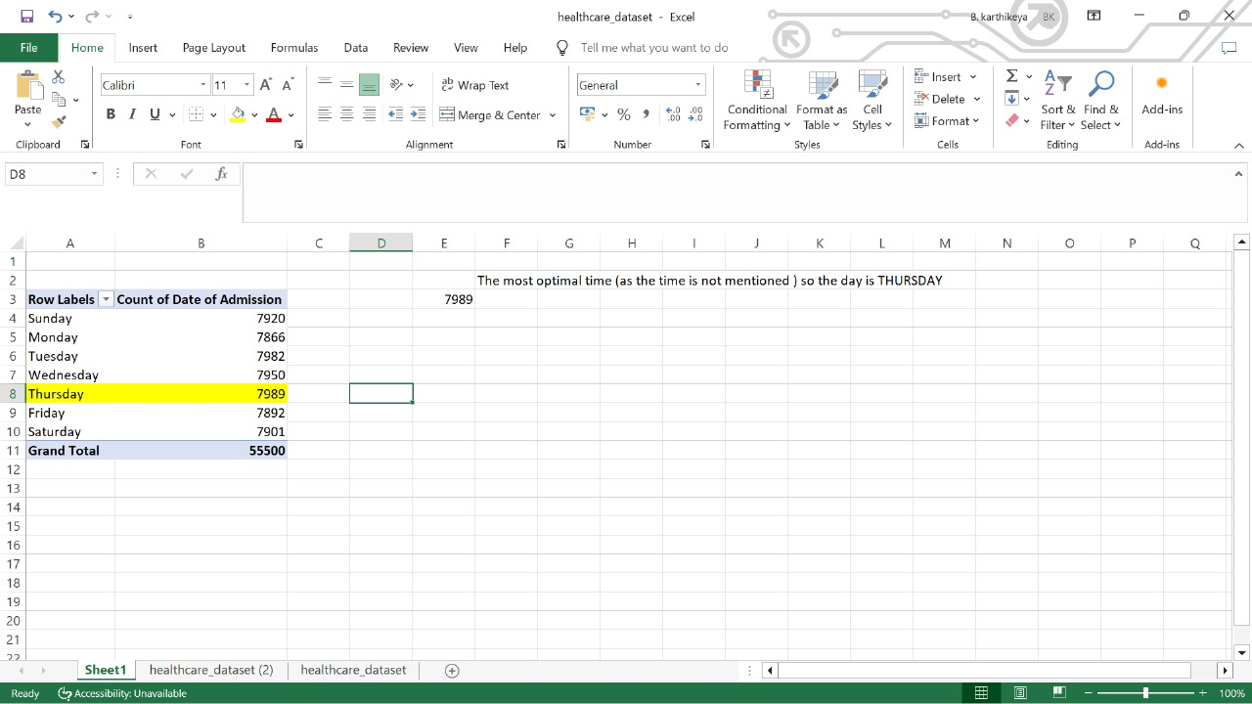

FOURTH QUESTION

1.To identify the most frequently paired medical condititon and medication .Now , create a pivot table using these two columns and name column

2. Drag the CONDITION to “rows” and MEDICATION to”columns” and Patient name to values .

3. Now , you will get the common pairings of the medication and Condition , from that where the highest value is present at that box the row name of condition and column name of medication is the most frequently paired medical condition and medication .

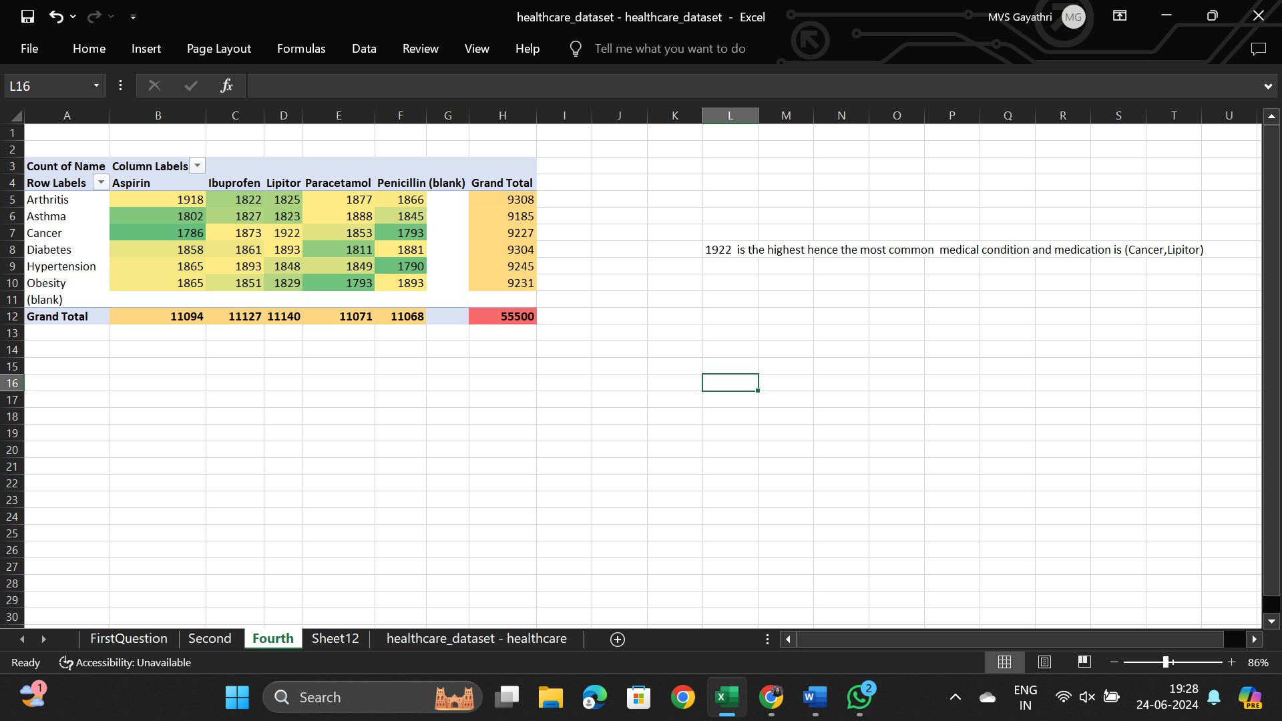

FIFTH QUESTION

1.To determine which medical condition is most expensive you need the columns called “Condition” and “Billing”

2. Insert a pivot table using dataset and drag “CONDITION” to the rows and “Billing Amount ” to the columns .

3. Now calculate the AVERAGE of billing with respect to the Condition using the pivot table .

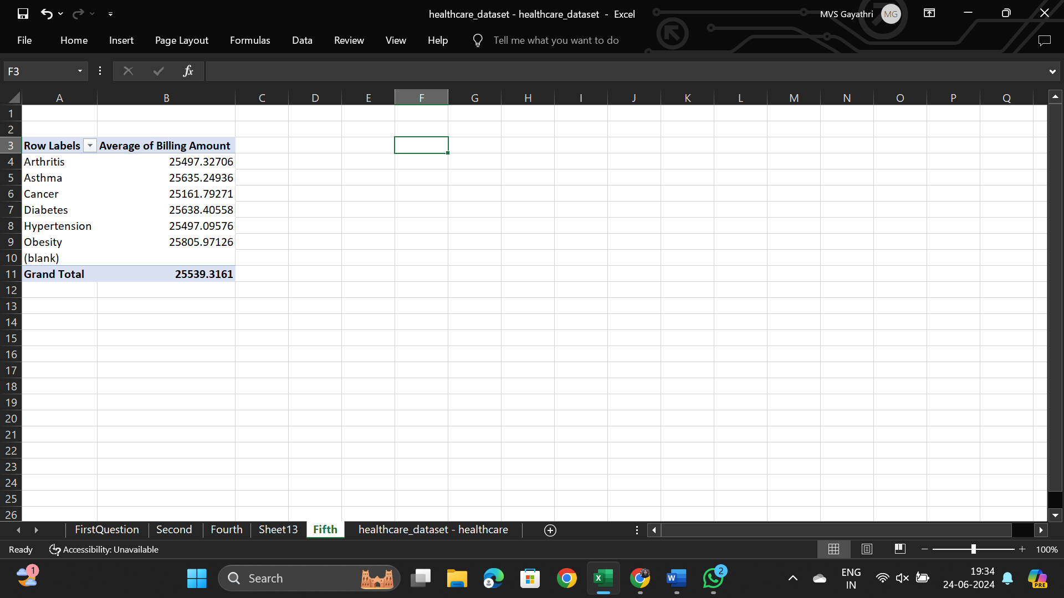

1. Now sort the column of AVERAGE OF BILLING AMOUNT in descending order .

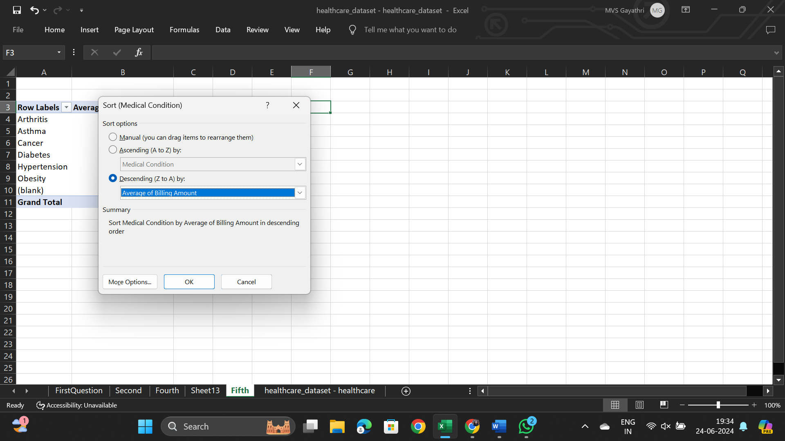

1. **Most Expensive Medical Condition and Hypothesis on Costs is OBESITY**
2. 